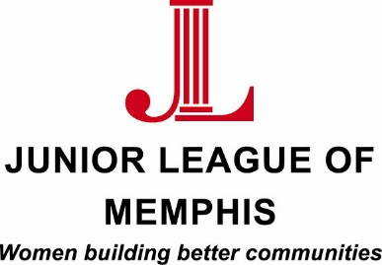

Contact:
Sarah Wright, Junior League of Memphis Marketing/PR Chair
901-552-7762
sarahwright331@gmail.com

Lauren Price, Junior League of Memphis Communications Director
901-219-6923
lauren.mabon@gmail.com

FOR IMMEDIATE RELEASE

Junior League of Memphis to host second annual Bridal Show

MEMPHIS, TENN. – October 26, 2015 – The Junior League of Memphis (JLM) will host its second annual Bridal Show this Sunday, Nov. 1, 2015, from 1 to 5 p.m.at the JLM Community Resource Center (CRC). At the show, brides-to-be will have the opportunity to see first-hand the indoor and outdoor space of the CRC.

The show will feature local and regional vendors; including Andria Lewis Events, Angela Mazanti Event Planning, Classic Party Rentals, Curtain Call, Eden Spa, Gia Marina, Holly & Ivy, Hollywood R&P Productions, Hotshots Photobooth, musician Jeremy Shrader, Simply Delicious Catering, Southern Bride Magazine, Southern Charm Event Group, Studio 78, and Two Doors Down.

The JLM CRC is located at 3475 Central Avenue. For more information and to see the most up- to-date vendor list, visit https://www.jlmemphis.org/events/jlm-bridal-show/

About the Junior League of Memphis
The Junior League of Memphis (JLM) is an organization of women committed to promoting voluntarism, developing the potential of women, and improving communities through the effective action and leadership of trained volunteers. Its purpose is exclusively educational and charitable. As one of the largest volunteer groups in the Mid-South, the JLM is committed to revitalizing neighborhoods in and around Memphis through the development of, and participation in, programs that positively impact the environments where people live, work and play.
# # #

