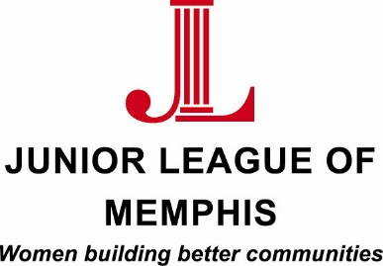

Contact:
Sarah Wright, Junior League of Memphis Marketing/PR Chair
901-552-7762
sarahwright331@gmail.com

Lauren Price, Junior League of Memphis Communications Director
901-219-6923
lauren.mabon@gmail.com

FOR IMMEDIATE RELEASE

Junior League of Memphis to host Merry Marketplace

MEMPHIS, TENN. – October 28, 2015 – The Junior League of Memphis (JLM) Merry Marketplace is just two weeks away, and a great place to pick up unique handmade gifts for someone on your shopping list this holiday season. This year’s event will be held at The Racquet Club of Memphis, located in the heart of East Memphis.

The show begins Thursday, Nov. 12 and runs through Saturday, Nov. 14. General admission tickets are $10 and can be purchased online or at the door. General admission shopping dates and times are Friday, Nov.13 from 9 a.m. to 5 p.m. and Saturday, Nov. 14 from 9 a.m. to 5 p.m.

Special Events for the show are listed below:
- Girl’s Night Out presented by Baptist Memorial Health Care: Thursday, Nov. 12 from 6– 9 p.m. Tickets are $25.00.
- Merry Marketplace Morning: Friday, Nov. 13 from 9 to 10:30 a.m. Enjoy mimosas and muffins and stroller free shopping. Tickets are $25.00.
- Saturday with Santa: Saturday, Nov.14 from 9 to 11 a.m. Ticket includes admission into show and one picture with Santa. Tickets are $30.00.

This event serves as a major fundraiser for the JLM. Funds raised support the JLM’s ongoing efforts to improve the Memphis community.

For more information visit our website or follow The JLM Merry Marketplace page on facebook.

About the Junior League of Memphis
The Junior League of Memphis (JLM) is an organization of women committed to promoting voluntarism, developing the potential of women, and improving communities through the effective action and leadership of trained volunteers. Its purpose is exclusively educational and charitable. As one of the largest volunteer groups in the Mid-South, the JLM is committed to revitalizing neighborhoods in and around Memphis through the development of, and participation in, programs that positively impact the environments where people live, work and play.
# # #

