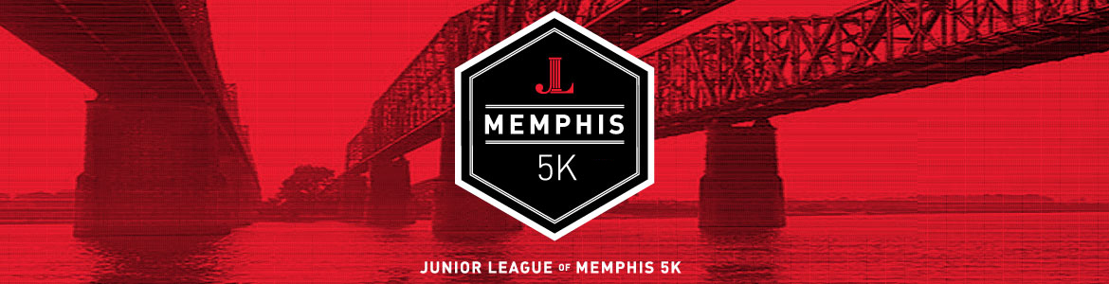
May 9, 2020
https://www.jlmemphis.org/events/jlm-5k

The Pyramid ($5,000 donation):
- Presenting Sponsor (only 1)
- Top billing placement of logo on official race shirt and race signage
- Advertising/Logo on water stations
- Advertisement on banners positioned at the race
- Logo on race website with link to company website
- Advertising in goody bag that each participant receives
- Ten race entries and t-shirts

Bluff City ($2,500 donation):
- Premium placement of logo on official race shirt and race signage
- Advertising/Logo on water stations
- Advertisement on banners positioned at the race
- Logo on race website with link to company website
- Advertising in goody bag that each participant receives
- Eight race entries and t-shirts

Ten Feet Off Of Beale ($1,500 donation):
- Name/logo on the race t-shirt - Mid level, Tier 3
- Advertisement on banners positioned at the race
- Logo on race website with link to company website
- Advertising in goody bag that each participant receives
- Six race entries and t-shirts

Blue Suede Shoes ($1,000 donation):
- Name/logo on the race t-shirt – Tier 2
- Logo on race website with link to company website
- Advertising in goody bag that each participant receives
- Four race entries and t-shirts
Grind City ($500 donation):
- Name/logo on the race t-shirt – Tier 1
- Logo on race website with link to company website
- Advertising in goody bag that each participant receives
- Three race entries and t-shirts

The 901 ($250 donation):
- Advertising in goody bag that each participant receives
- Name on race website
- Two race entries and t-shirts

Memphian ($100 donation):
- Name on race website
- One race entry and t-shirt

