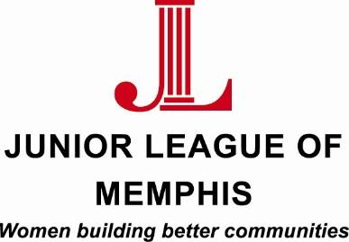

Contact:
Cara Sievers, Junior League of Memphis Impact Engagement Director
901-219-0704
carabethe@gmail.com

Lauren Price, Junior League of Memphis Communications Director
901-219-6923
lauren.mabon@gmail.com

FOR IMMEDIATE RELEASE

Junior League of Memphis Presents Panel at 41st Annual Neighborhoods USA Conference

MEMPHIS, TENN. – May 19, 2016 –The Junior League of Memphis (JLM) is presenting a panel at the upcoming Neighborhoods USA conference. The panelists will discuss how it has revitalized Memphis neighborhoods through collaborative community initiatives.

JLM president, Amy Stack, along with fellow JLM members Stephanie Simpson and Nicole Erwin will be joined by Walter Casey, director of the Lester Community Center, and Dr. Angela Askew, principal of William H Brewster Elementary.

"The JLM is thankful for the partnerships we share in Binghampton and Berclair/Highland Heights that have deepened our knowledge of and commitment to Memphis,” said Stack. “We are honored to share what we've seen over and over again - committed people working together with a shared vision can lead to incredible change."

In 2009, the JLM’s G.R.O.W. (Giving Readiness, Opportunities, Wellness) program launched and has involved more than 200 dedicated volunteers and more than $136,000 in funding support. G.R.O.W. has made an increasing impact on the Binghampton community for the past six years, and in 2015, the program was expanded to the Berclair/Highland Heights area.

“When creating the blue print for the G.R.O.W. program, one of the goals was to replicate the model in multiple neighborhoods with the support of a variety of partners,” said Simpson. “It is exciting to see this achieved through our expansion in the Berclair community, and we look forward to further developments in the future.”

"The JLM hopes this model of programming is something that can be replicated in multiple neighborhoods and by a variety of agencies across Memphis," Simpson continued.

Panelists will speak to the challenges associated with building a program such as this; the importance of building strategic relationships in the selected community; and the types of programming that have been most successful for this initiative.

"The JLM knows that Memphis is the Place To Be – and we are working to revitalize our neighborhoods, one community at a time," Stack said.

About the Junior League of Memphis
The Junior League of Memphis (JLM) is an organization of women committed to promoting voluntarism, developing the potential of women, and improving communities through the effective action and leadership of trained volunteers. Its purpose is exclusively educational and charitable. As one of the largest volunteer groups in the Mid-South, the JLM is committed to revitalizing neighborhoods in and around Memphis through the development of, and participation in, programs that positively impact the environments where people live, work and play.

About Neighborhoods USA
Neighborhoods, USA is a national non-profit organization committed to building and strengthening neighborhood organizations. Created in 1975 to share information and experiences used to build stronger communities, NUSA continues to encourage networking and information-sharing to facilitate the development of partnerships among neighborhood organizations, government and the private sector for the ultimate goal of strengthening every neighborhood.
# # #

