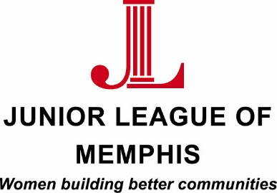

Contact:
Sarah Wright, Junior League of Memphis Marketing/PR Chair
901-552-7762
sarahwright331@gmail.com

Lauren Price, Junior League of Memphis Communications Director
901-219-6923
lauren.mabon@gmail.com

FOR IMMEDIATE RELEASE

Junior League of Memphis Repeat Boutique to Celebrate 70th Birthday

MEMPHIS, TENN. – August 24, 2015 – The Junior League of Memphis (JLM) thrift shop, Repeat Boutique, is celebrating its 70th birthday with a sidewalk sale at the store Saturday, August 29. The JLM has operated a thrift shop since the early 1940s, with the first shop being housed in a JLM member’s basement. The shop moved to various parts of town, from Main Street to midtown, before finding its current location Summer Avenue. The purpose of the JLM’s thrift shop efforts has remained the same: sell quality merchandise at affordable prices and invest proceeds from the shop’s sales into services, projects and programs that impact the community.

The Repeat Boutique is a resale shop operated by the JLM. The store sells gently used clothing, shoes and accessories for all ages; small home furnishings; housewares; and children’s items. Junior League of Memphis members donate most of the items sold at the store, however, several local companies made contributions to the upcoming sidewalk sale. IO Metro has donated new furniture including sectionals, occasional chairs and dressers.

Amy Stack, JLM President, reminisced about her first experience with Repeat Boutique.

“I witnessed the dual mission of the Repeat Boutique firsthand during my first-ever volunteer shift as the store,” said Stack. “As I was straightening up a clothes rack, a customer came up to me and shared that she was starting a brand new job at an office and needed help putting together some business professional outfits. What a fun time we had talking about her new job, how hard she had worked to get the opportunity, and we found some great bargains that made her feel like a million bucks and ready to take the professional world by storm! The funds the JLM raises through the Repeat Boutique are so critical to our work in the community, but the quality merchandise at affordable prices are also a great service to our customers and patrons. It’s truly a win-win.”

The Repeat Boutique is open Tuesday – Saturday 10 a.m. to 5 p.m. and is located at 3586 Summer Avenue.

About the Junior League of Memphis
The Junior League of Memphis (JLM) is an organization of women committed to promoting voluntarism, developing the potential of women, and improving communities through the effective action and leadership of trained volunteers. Its purpose is exclusively educational and charitable. As one of the largest volunteer groups in the Mid-South, the JLM is committed to improving the lives of women and children in the Memphis community.
# # #

