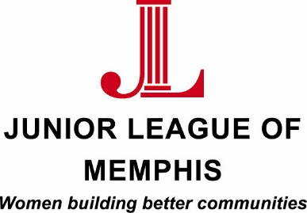

Contact:
Sarah Wright, JLM Marketing/PR Chair
901-552-7762
sarahwright331@gmail.com

Lauren Price, JLM Communications Director
901-219-6923
lauren.mabon@gmail.com

FOR IMMEDIATE RELEASE

Junior League of Memphis Recognizes 2014-2015 Volunteers of the Year

MEMPHIS, TENN. – June 17, 2015 – The Junior League of Memphis (JLM) announced the winners of the 2014-2015 Volunteer of the Year Awards. These JLM members serve the Memphis area community through their yearly volunteer commitments and work tirelessly to assist the JLM’s community projects as well as support the leadership teams.

“We are excited to recognize the efforts and accomplishments of these members of the Junior League of Memphis,” said JLM President Amy Stack. “These women exemplify the mission of the JLM and, with their support, we are able to do incredible things in the Memphis community in terms of hands-on service, funding support to community projects and partners and developing women as trained volunteers and community change agents.”

The winners of the awards are:

Community Volunteer of the Year
Mary Grodsky

Communications Volunteer of the Year
Kate Bass

Financial Volunteer of the Year
Peria Gober

Membership Volunteer of the Year
Rebecca Fava

Paula Landgschmidt Thrift Shop Award
Brooke Levy

Provisional Member of the Year
Jennifer Coltharp

Sustainer of the Year
Pamela Palmer Montesi

Training Volunteer of the Year
Anjelica Hardin

Volunteer of the Year
Tealy Hewgley

Teri Schneider Spirit of the JLM
Cathy Ainsworth

Helping Hands Award
Central Printing
Barry Crump

Helping Hands Award
Alice Davis
Lester Community Center

About the Junior League of Memphis
The Junior League of Memphis (JLM) is an organization of women committed to promoting voluntarism, developing the potential of women, and improving communities through the effective action and leadership of trained volunteers. Its purpose is exclusively educational and charitable. As one of the largest volunteer groups in the Mid-South, the JLM is committed to improving the lives of women and children in the Memphis community.
# # #

